**Airline Passenger Dashboard Report**

This report summarizes insights from the Airline Passenger Dashboard across five pages:

**Passenger Overview**

* **Total Passengers:** 129,880
* **Male Passengers:** 63,981 (49.3%)
* **Female Passengers:** 65,899 (50.7%)
* **Types of Travel:** Business and Personal
* **Customer Types:** First-time and Returning
* **Class Categories:** Business, Economy, Economy Plus

This overview provides a **demographic and categorical breakdown** of passengers.

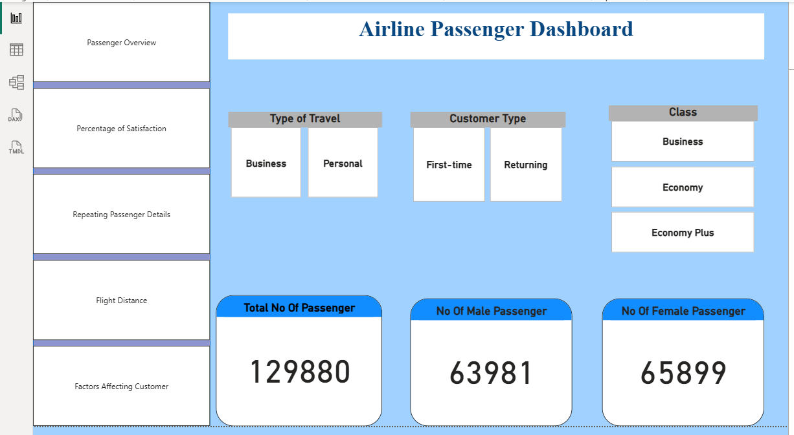

Percentage of Satisfaction

* **Overall Passenger Satisfaction:**
  + Returning customers have **higher dissatisfaction (42.63%)** compared to satisfaction (39.06%).
  + First-time customers show lower dissatisfaction (13.92%) and a small percentage of satisfaction (4.39%).
* **By Type of Travel:**
  + **Business Travelers:** Higher satisfaction (40.31%) compared to dissatisfaction (28.75%).
  + **Personal Travelers:** Very low satisfaction (3.14%) and similar dissatisfaction (27.81%).

**Which percentage of airline passengers are satisfied? Does it vary by customer type? What type of travel?**

**Answer:**

* Around **43% of passengers are satisfied overall**.
* **Satisfaction varies strongly by travel type** – business travelers are far more satisfied than personal travelers.
* Returning customers tend to report more dissatisfaction compared to first-time flyers.

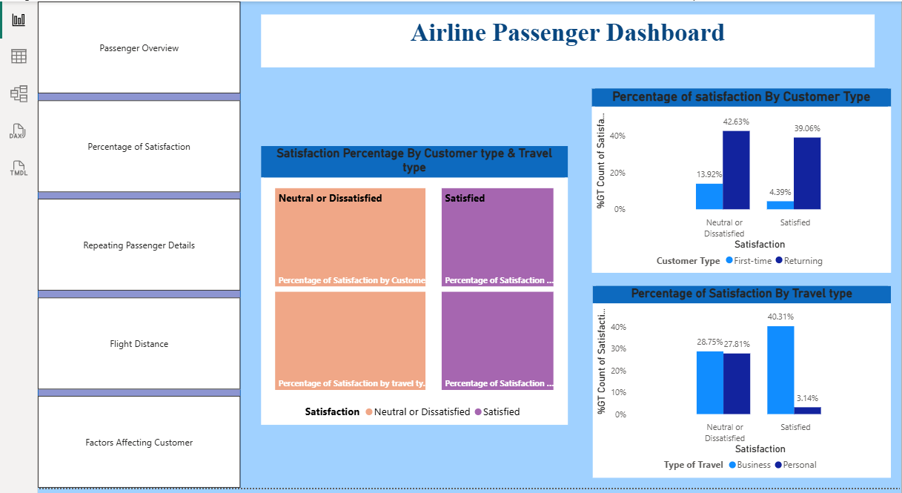

Repeating Passenger Details

**Repeating Passengers:** 106,100 (majority of total passengers).

**Customer Profile of Repeating Passengers:**

* Age distribution: Many repeat travelers are **between 15–24 years old**.
* Gender: Almost evenly split (Male: 50.01%, Female: 49.99%).
* Travel & Customer Type: Repeating passengers are **mostly Business travelers**, with far higher satisfaction compared to personal travelers.

**What is the customer profile for a repeating airline passenger?**

**Answer:**

Repeating airline passengers are typically between 15 and 24 years old, with males and females almost evenly represented. Most of them travel for business, and they tend to show higher levels of satisfaction compared to others.

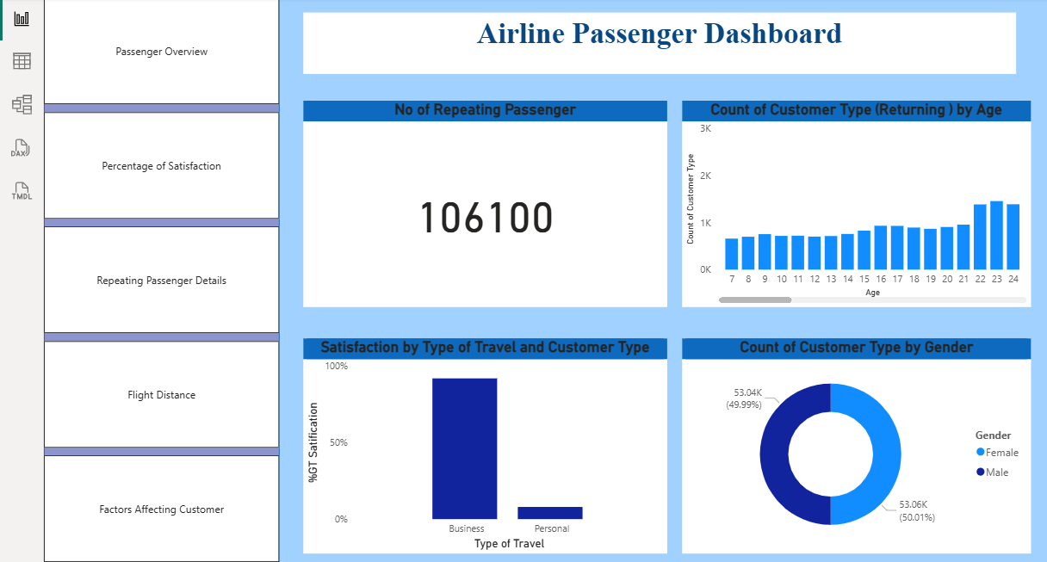

Flight Distance

**Passenger Travel by Distance:**

* **Medium and High distances** have more passengers compared to short distances.
* Returning passengers dominate medium & high distances.

**Satisfaction by Distance:**

* Seat comfort, food, and in-flight services are rated **higher for longer flights**.
* Short-haul passengers report **lower comfort and satisfaction**.

**Does flight distance affect customer preferences or flight patterns?**

**Answer:**

Longer flights → higher satisfaction (better services like food, comfort).

Short flights → less satisfaction, possibly due to limited services.

Most repeat travelers prefer medium and long-haul flights.



Factors Affecting Customers

* **Top Positive Factors (High Ratings for Satisfied Customers):**
  + Online Boarding
  + On-board Service
  + Leg Room Service
  + In-flight Wi-Fi & Entertainment
  + Baggage Handling
* **Areas of Dissatisfaction (Drop in Neutral/Dissatisfied group):**
  + Seat Comfort
  + Check-in Service
  + Cleanliness
  + In-flight Service

**Which factors contribute to customer satisfaction the most? What about dissatisfaction?**

**Answer**

* **Contributing most to satisfaction:** Online boarding, in-flight Wi-Fi, on-board service, baggage handling.
* **Contributing most to dissatisfaction:** Seat comfort, check-in, and cleanliness.

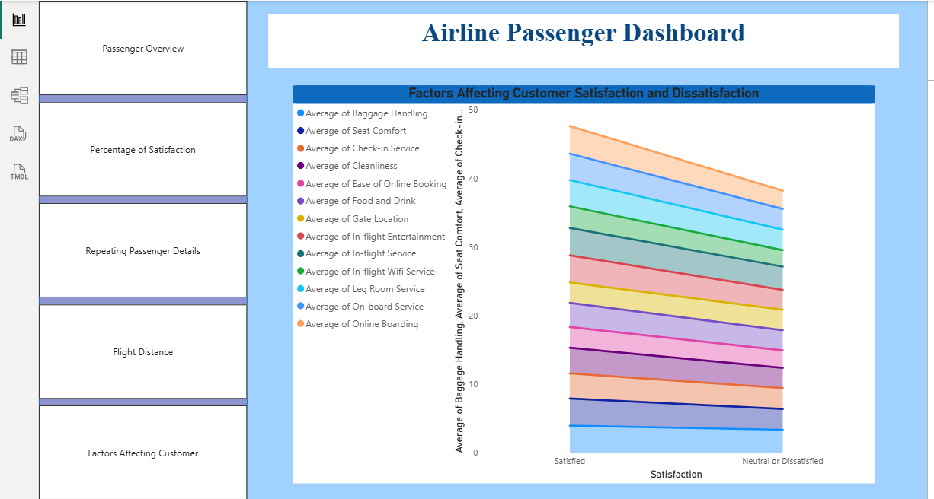

## Overall Insights

1. **Satisfaction:** About 43% of passengers report being satisfied, with business travelers and those on longer flights showing the highest satisfaction levels.
2. **Customer Type:** Most passengers are returning flyers, though they tend to be less satisfied compared to first-time customers.
3. **Repeating Passengers:** These are generally younger (ages 15–24), evenly split between male and female, and mostly travel for business purposes.
4. **Flight Distance:** Passengers on longer routes usually have a better overall experience and express greater satisfaction.
5. **Satisfaction Factors:** Positive experiences are mainly influenced by online services and in-flight amenities, while issues like seat comfort and the check-in process contribute to dissatisfaction.